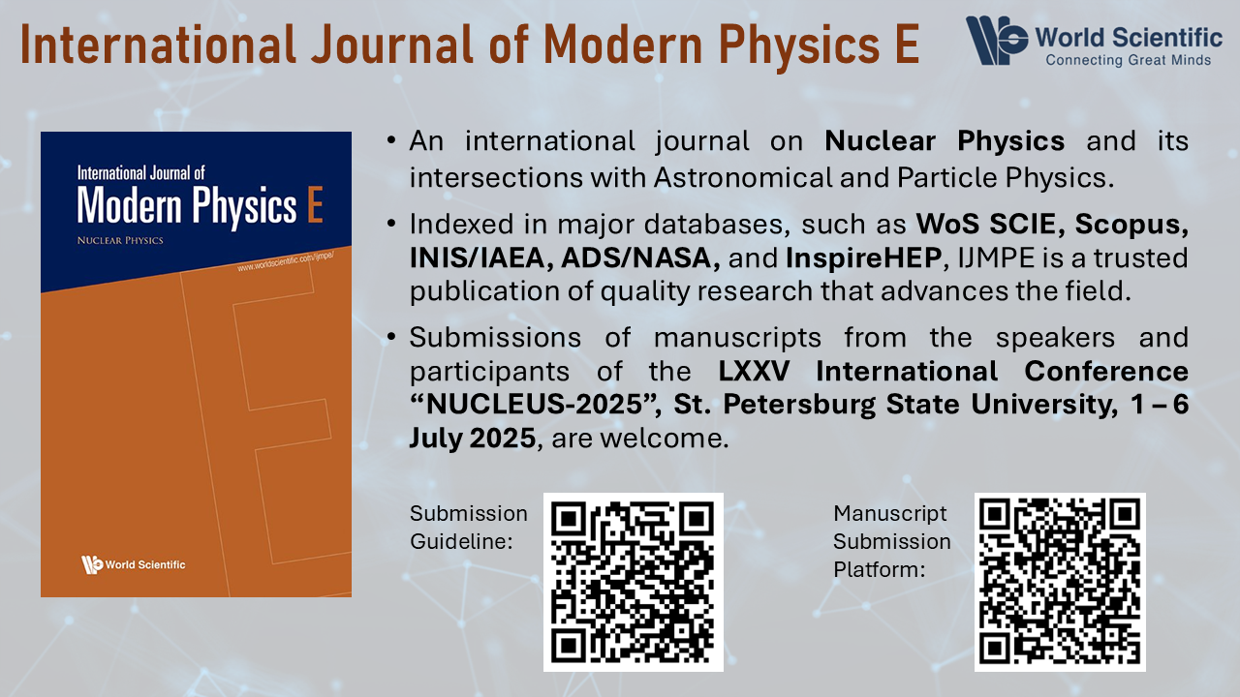

IJMPE Selected Papers of Nucleus-2025 (St. Petersburg State University)
- Instructions for preparation of IJMPE manuscripts are available in: LaTeX2e (readme / Download).
More info: https://www.worldscientific.com/page/ijmpe/submission-guidelines
- Recommended manuscript length: 10 – 20 pages.
- Manuscript submission due date: 30 September 2025.
- Submit your manuscript to IJMPE website: https://www.editorialmanager.com/ijmpepage
- After logging into the system, click on the Submit New Manuscript .
- Next, please select Selected Papers: Nucleus-2025 (SPbU) .
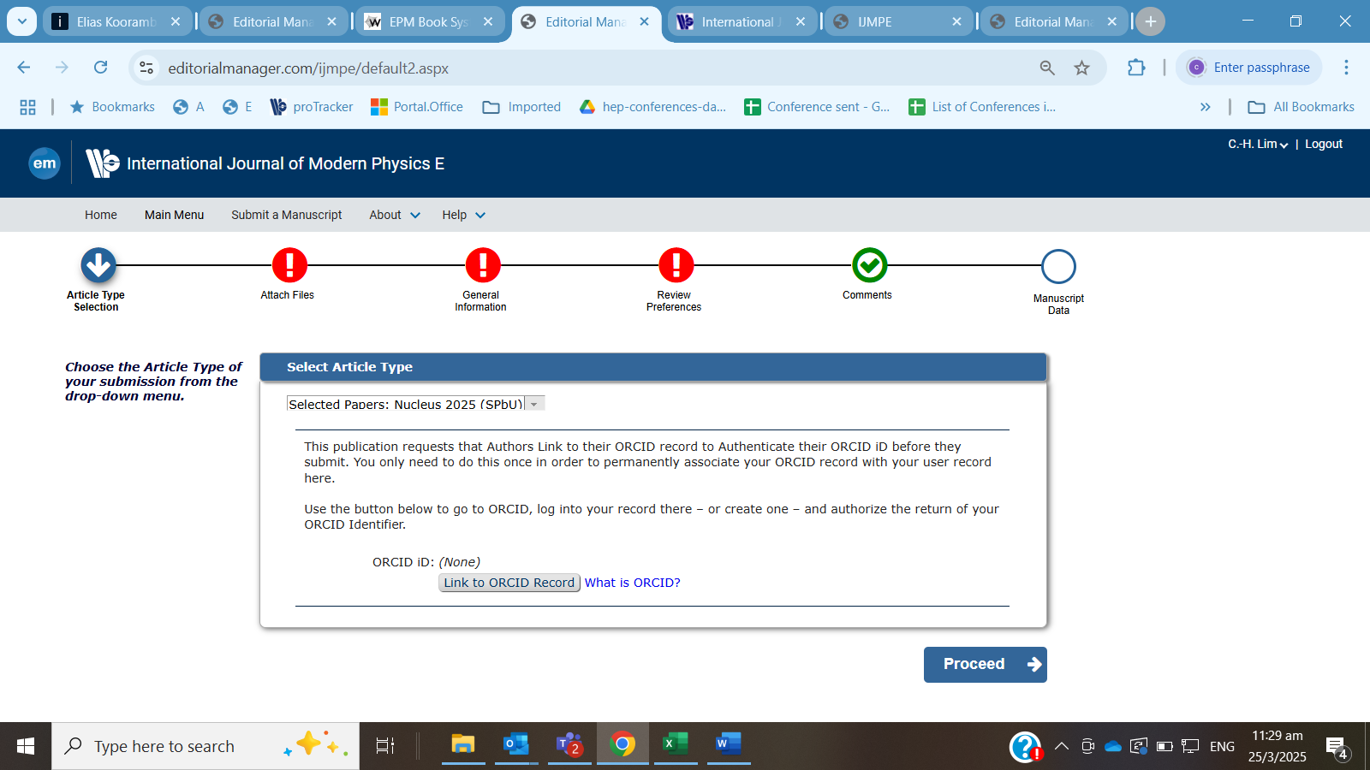
and follow by authenticating ORCID id of the Corresponding Author.
- Proceed to the next steps. At the last step, please click on Build PDF for Approval .
- Remember to view the PDF and click Approve Submission to complete the submission process.
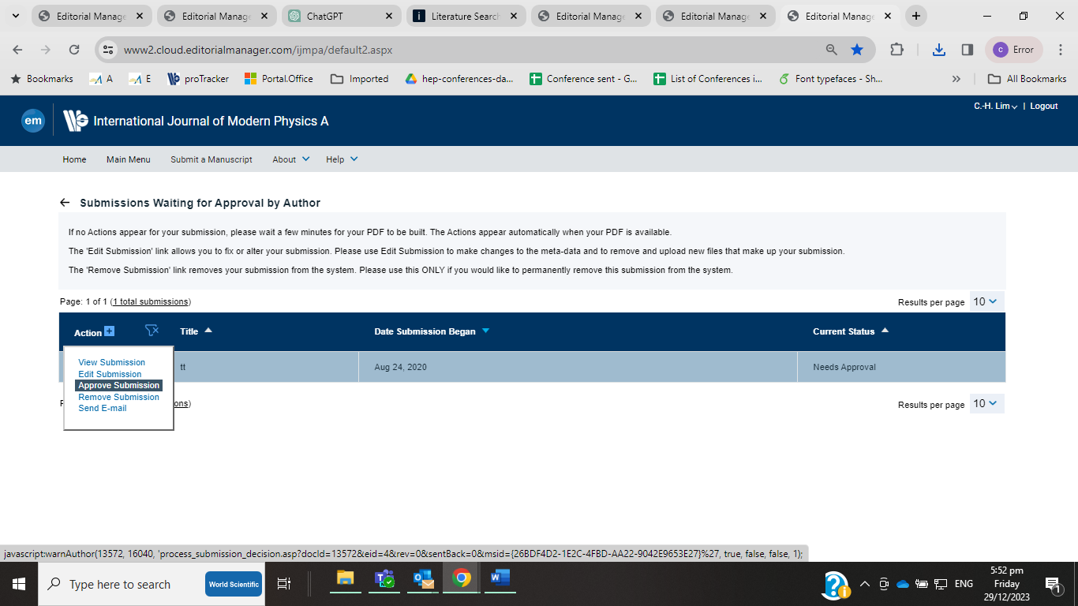
- If there are queries about manuscript submissions, please contact the Mr C H Lim at Journal Office by email to ijmpe@wspc.com

